External Interface Requirements

# User Interfaces

1. 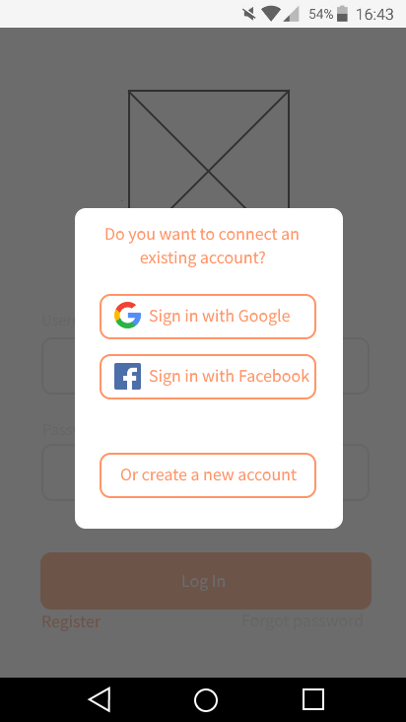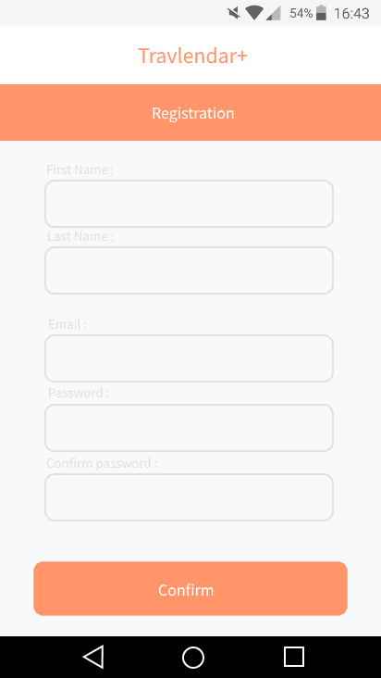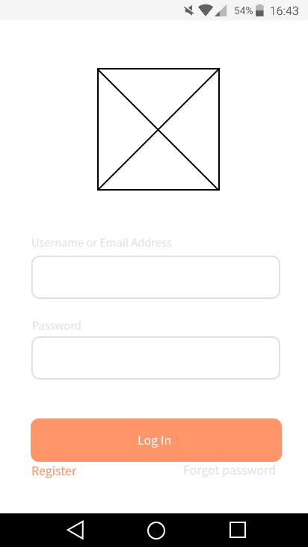Login page:
2. 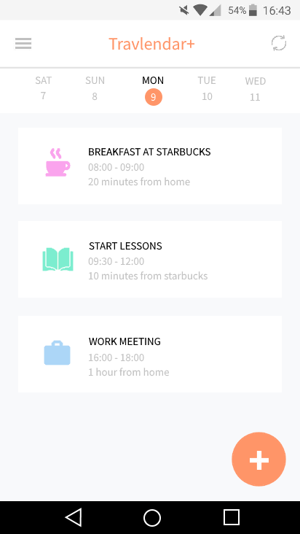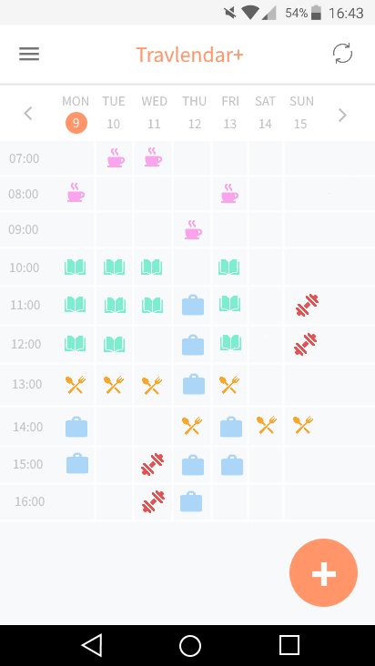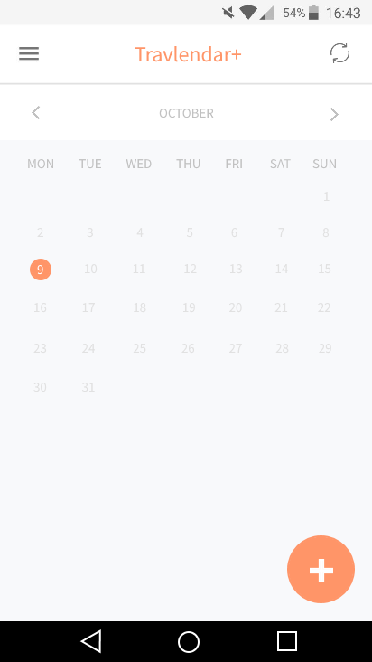Homepage:
3. Left panel (option panel):

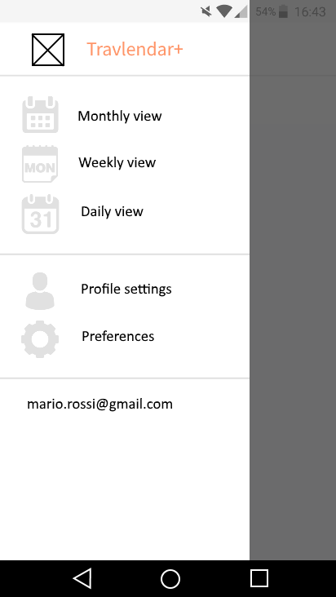

1. Create new appointment and related popup:

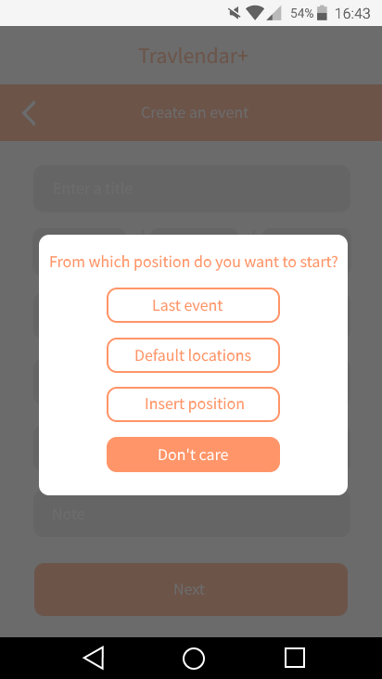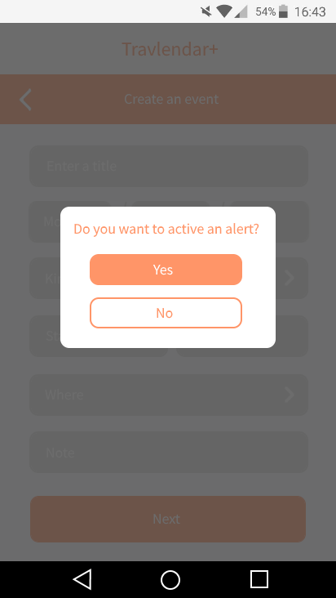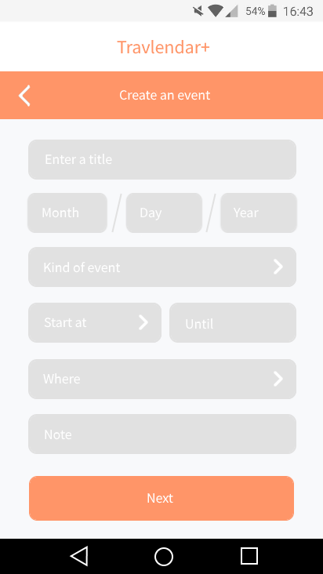

1. Preferences settings:

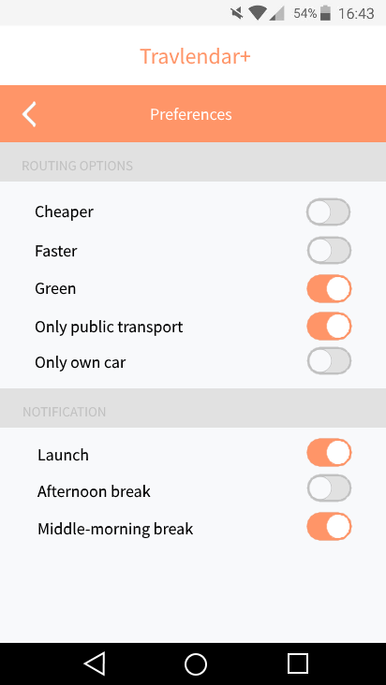

## Software interface:

Inside application are used different API (Application programming interface):

* Weather API: <https://openweathermap.org/api>
* Google Maps API: <https://developers.google.com/maps/>
* Trenord API: <https://github.com/bluviolin/TrainMonitor/wiki/API-del-sistema-Viaggiatreno>
* Car2go API: <https://github.com/car2go/openAPI>
* Enjoy API: <https://github.com/mattiaongit/enjoy/blob/master/enjoy.py>
* BikeMi API: <https://github.com/pierlauro/bikemi-unofficial-api>
* MoBike API: <https://github.com/ubahnverleih/WoBike>

# Design constraints

Standards compliance

The application must require to the user different permissions:

* Access to the calendar;
* Get his position with GPS;
* Access to device storage.

## Hardware limitations

The application, at the moment, runs only on Android 4.0.3 version or newer.

The device needs:

* Internet connection;
* GPS;
* Space for save application in memory.

Actual devices on the market satisfy all these requirements.